Developing and using my language appropriately

**Learning outcome:**

Listens with acuity for information and enjoyment and responding appropriately in a wide range of situation.

**Competence:**

Responds to different sounds.

**Material:** flash cards, real objects, charts, visual aids.

**Procedure:**

* The lesson will begin with a song

Clap your hands x 2

Listen to the music

And clap your hands

**LESSON 1**

Let the teacher introduce the sources of sound in the environment.

**Learner’s activity:**

Let learners recognize and shade the source of sound



**LESSON 2**

* The teacher will introduce the lesson with a song

Stamp your feet x 2

Listen to the music

And stamp your feet

* The teacher will introduce the source of sound.

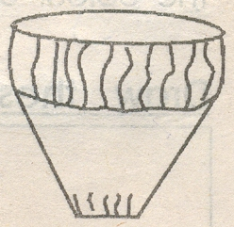

* The learners will recognize and tell the source of sound.

**Learner’s activity**

Let the learners identify the drum and shade it.

**LESSON 3**

**Procedure:**

* Let the teacher introduce the lesson with a song

Turn around x 2

Listen to the music

And turn around

* Let the teacher introduce the source of sound to learners i.e radio
* Let learners identify and learn the whistle.
* Let the pupils shade the radio

**Activity:**

Shade the radio

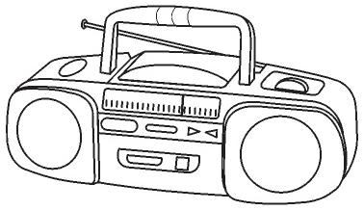

**LESSON 4**

**Procedure:**

* Let the teacher introduce the lesson with a song

I am a music man

I come from far away

And I can play, what can you play?

A can play piano

Pia pia pia noo x 3

* Let the teacher review all the three sources of sound i.e

  

* Let the pupils tell the sources of sound i.e television, drum, radio

**Activity:**

Match the sources of sound

 

 

 

Developmental activities:

Telling the direction of the sound a pupil will drum from a certain corner and then the rest will have to tell where the sound has come from.

Lesson 5:

Sounds made by different animals.

Materials: visual aids

Procedure:

* The teacher will introduce the lesson with a song.

There is a little cat

Mwe x 2

Far in the forest

Singing very swiftly and that’s

Very nice

* The teacher will introduce the sounds made by different animals. E.g

Snake – sss

Cow – mooo

Dog – bow bow

Cat – mew

* Learners will make the sounds of different animals.

**Activity:**

Match the same

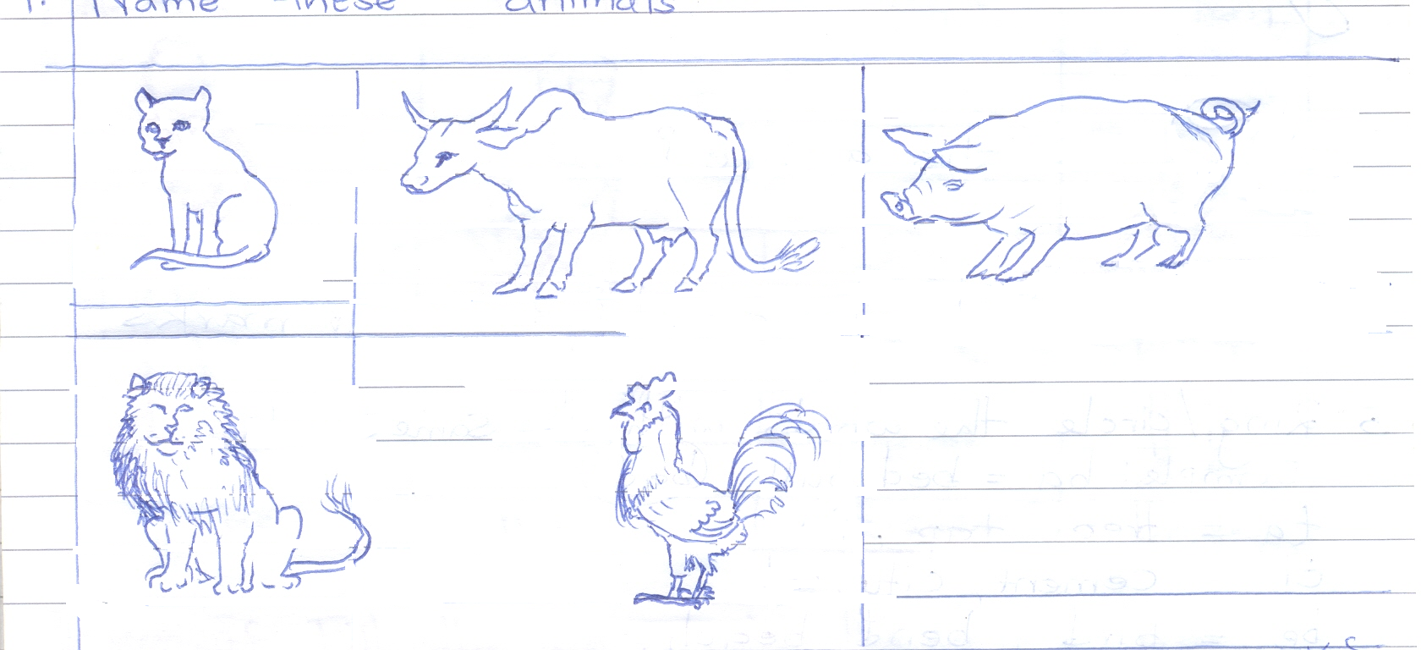 AN02609_

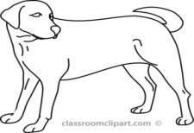 

AN02609_ 

**LESSON 6**

Sounds in a given order.

**Materials:** cut outs, cards

**Procedure:**

* Let the teacher introduce the lesson with a rhyme.

The snake is in the grass x 2

S s the snake is in the grass

* Let the teacher introduce sound ‘S’ and it’s picture to the pupils.
* Let the pupils recognize and tell the sound with its pictures i.e

S NA00809_

AN02609_

**Activity:**

Trace sound S

Write the sound

S S S

**LESSON 7**

**Procedure:**

* Let the teacher review sound‘s’ with its pictures.
* Let the learners tell the sound with its pictures i.e

S NA00809_

AN02609_

**Activity:**

Shade the sound Shade the pictures.

NA00809_ 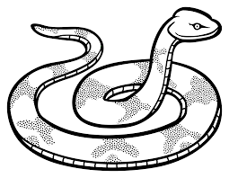

**LESSON 8**

**Materials**: cards, cut outs, visual aids

**Procedure:**

* The teacher will introduce the lesson with a song

a a ants on my arm x 2

They are causing me alarm

* The teacher will review sound ‘S’ with its pictures
* The teacher will introduce sound ‘a’ with its pictures i.e

a 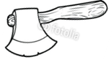

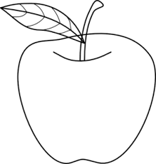

* The learners will learn and identify sound ‘a’

Activity

Trace the sound

Write the symbol

0 I 0 I 0 I

0 I 0 I 0 I

**LESSON 9**

* The teacher will review sound ‘s’ and ‘a’
* The teacher will ask the pupils to tell the sounds ‘s’ and ‘a’

**Activity:**

Write sound a

a a a

a a a

Shade the pictures

 

**LESSON 10**

**Materials:** cards , cutouts, visual aids

**Procedure:**

* The teacher will introduce the lesson with a song

a a ants on my arm x 3

they’re causing me alarm

* The teacher will review the precious sounds and pictures.
* Pupils will tell the sounds.

**Activity**

Match the same

S a

a S

Match the same

AN02609_ 

NA00809_ 

 AN02609_

 NA00809_

**LESSON 11**

**Materials:** cards, cut outs

**Procedure:**

* The teacher will introduce the lesson with a rhyme

When I am watching

The tennis game t t t x 2

My head goes back and forth

* Teacher will teach the new sound (t) to the learners.
* Teacher will ask learners to do the action for the sound
* Learn the pictures for the sound

**Activity:**

Learners will shade the sound and its pictures.

**LESSON 1**

Trace the sound

**LESSON 2 AND 3**

Shade the sound and picture

BD07846_

**LESSON 4 AND 5**

Match the same sound

a t

s a

t s

**LESSON 6**

Circle the same

NA00809_ NA00809_

 BD07846_ 

AN02609_ AN02609_ 

**LESSON 7 AND 8**

Shade the sound and a picture

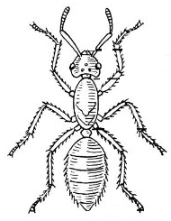 

Trace the sound

**Activity:**

Circle sound i

i t u

s a p i

i n

**LESSON 9 AND 10**

Shade the sound and pictures.

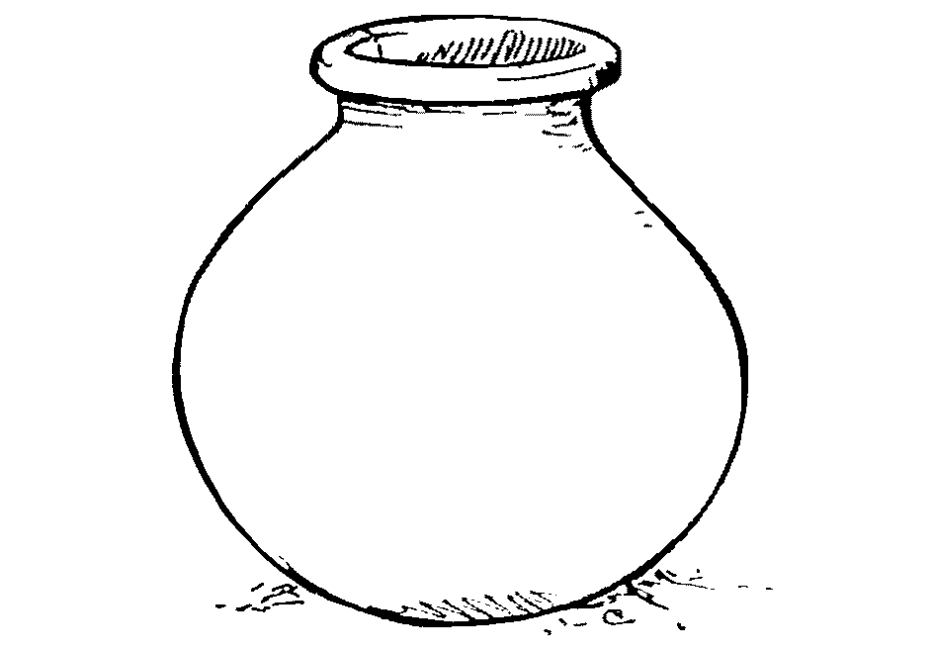

**Activity**

Trace and write

P p p

Circle the sound p

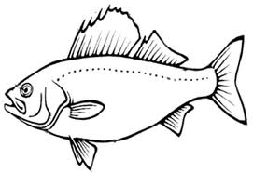

t s p a

P u p

**Lesson**

Shade the sound and its pictures

Trace and write

n n n

Match the same sounds.

s n

a p

t l

p s

l a

n t

**LO III**

Reading to enjoy, acquire knowledge and understanding (comprehension)

**Competence:**

Recognizes priorities and differences in objects, pictures and letter shapes.

**Materials:** real objects, charts, flash cards, visual aids

**Procedure:**

* Let the lesson start with a song

Chair, table x 2

Mr. Kakumba ---

* Show picture flash card and its sound
* Identifying

**Activity:**

Learn and sort the pictures (orally)

Trace the pictures

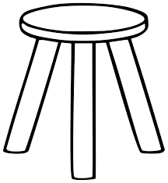Match the same pictures



BD04915_ HH01672_

 

HH01672_ BD04915_



Shade the pictures

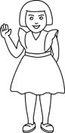  MCj03110200000[1] 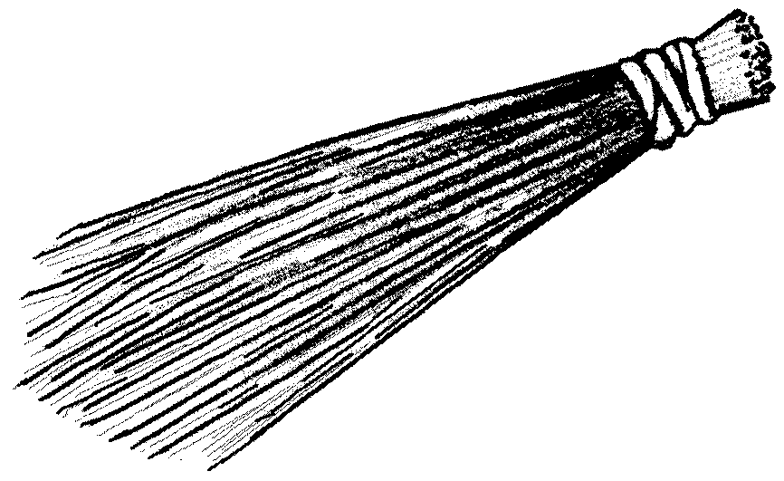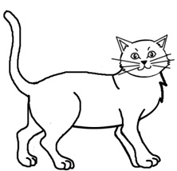

Cross the same pictures

 

BD07846_ 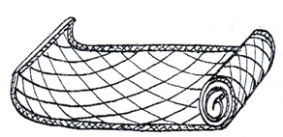 

SL01040_ BD07837_ SL01040_

BD07846_  

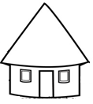  

Copy and draw

|  |  |  |  |
| --- | --- | --- | --- |
| HH01672_ |  | https://encrypted-tbn3.gstatic.com/images?q=tbn:ANd9GcQwWIhAC1PZN8BOCV9_I5u3zlvIAJlVVrqsoaOcVbeLz6JAWnGMweODMK-w | SL01040_ |

Circle the pictures

S HH01672_ p i SL01040_ a n t

**Competence:**

Recognizes the difference in letter shapes

**Materials:** flash cards, charts

**Procedure:**

* Let the lesson start with a song.

A for 

i.e follow the songs for sounds.

* Show flash cards
* Identify the sound and the pictures.

**Activity:**

1. **Learn and shade**

SL01040_ 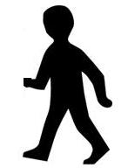 

 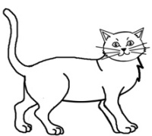 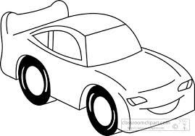

1. **Trace the sounds**

1. **Copy the sounds**

b b b c c c c

1. **Cross the same**

b b s

c a c

1. Trace the pictures

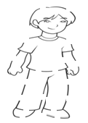 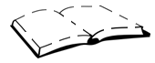 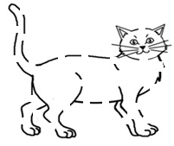 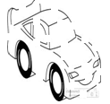

**LO IV:**

Writing different kinds of factual and imaginative tasks, depicting appropriate letter information, creativity and writing skills.

**Competence:**

Coordinates his / her eyes and hands effectively

**Material:** pencils, sticks, clay, papers, mud, sand, blocks.

**Activities:**

1. Scribble
2. Sort objects according to size

SL01040_



SL01040_ 

1. Match big and small
2. Learn the colours

red 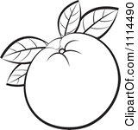 yellow

1. Match a picture to a colour

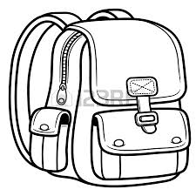 yellow

NA00809_ red

MORE PRACTICE WORK TERM 1

**LEARNING AREA 5 (READING)**

Sat pin

**s**

Shade

**a**

**t**

**p i**

**n**

Trace

**s**

**a**

**t**

**p i**

**n**

**Match the same**

s t

a s

t a

**Match**

p n

i p

n i

**Circle the same**

s t s

a a i

p t t

**circle the same**

p i p

i i a

t n n

**Copy and write**

|  |  |  |  |
| --- | --- | --- | --- |
| s |  | a |  |
|  |  |  |  |
| t |  | P |  |
|  |  |  |  |
| i |  | n |  |
|  |  |  |  |

**Match sound to picture**

S

a 

t 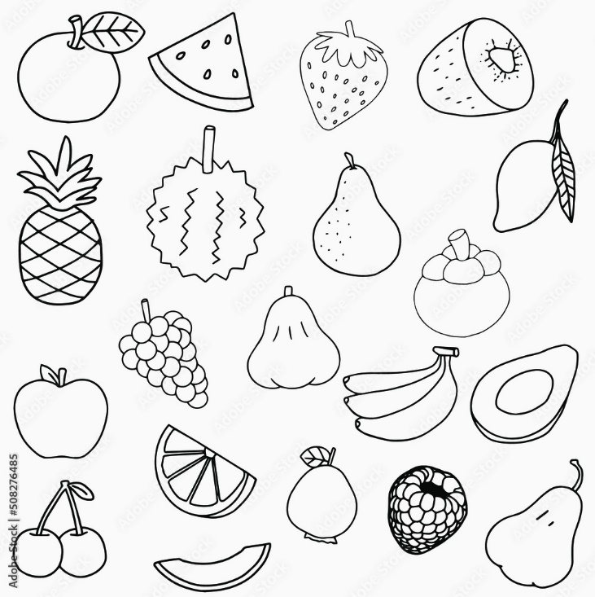

**Match**

p 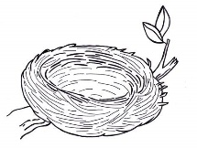

i 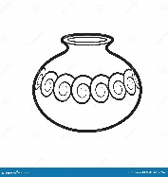

n ink

**Circle the correct picture for the sound**

s  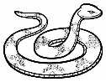

a 

t 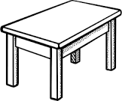 

**Circle the correct picture for the sound**

p 

i ink 

n  

**Colour the correct picture for the sound**

s  

a 

t  

**Colour the correct picture for the sound**

p 

i ink 

n  